## Costing & Deliverables:

| **Item** | **Approximate Costs** | **Average Delivery Time** |
| --- | --- | --- |
| **Product Redesign/Design** | 2000/- per design | 1-1.5 Weeks |
| **Website SEO** | 25000/- per month | Monthly |
| **Social Media Management (Instagram & Facebook)** | 15,000 per month for first 3 months  25,000 per month after | Monthly |
| **Product Catalog** | 10-15 rs per print (Paper)  Custom for cardboard | 1 week |
| **Milk Mug (Farmery logo)** | 95/- per mug | 2-3 weeks |
| **Jute Bag** | 150/- to 200/- | 2-3 weeks |
| **Jute Potli** | ~100/- | 2-3 weeks |
| **Insulated Flask/Bottle** | 300/- to 600/- | 2-3 weeks |
| **Basket** | Custom/Depends on items | 3-4 weeks |

## 

## Deliverables from Social Media Team

1. **Social Media Strategy**: We will develop a comprehensive social media strategy tailored to your brand, target audience, and marketing objectives. This strategy will serve as our roadmap for achieving success on social media platforms.
2. **Content Creation**: We will curate and create compelling and engaging content for your social media channels. This will include a ***mix of text, images, videos, infographics, and other multimedia assets*** to capture and retain the attention of your audience.
3. **Content Calendar:** We will establish a content calendar that outlines the planned posts, including their dates and times of publication. This will ensure a consistent and organized approach to content distribution across your social media platforms.
4. **Influencer Partnerships**: We will identify and collaborate with relevant influencers to expand your brand's reach and increase engagement. This will include managing influencer relationships, negotiating partnerships, and tracking the performance of influencer campaigns.
5. **Social Media Optimization:** We will continuously optimize your social media profiles and content to enhance visibility, engagement, and conversion rates. This may involve conducting A/B tests, experimenting with different post formats, and leveraging new features and tools offered by social media platforms.

We will be targeting a growth of **15%** in instagram and facebook every quarter.

Sample Products

| **Item** | **Approximate Price** | **Image** |
| --- | --- | --- |
| **Wall Clock** With brand Logo and Tagline | 330/- |  |
| **Insulated cup** with Lid | 250/- |  |
| Wall mounted **Key Holder**  With Branding, custom shape & design | 75/- |  |
| Metallic **Keyring** with leather strap | 85/- |  |
| **Umbrella** with subtle Farmery Branding | 230/- |  |
| Self Standing **QR Code Scanner** - cardboard | 45/- |  |

Farmery’s Marketing Plan (>6m)

## This marketing plan is modular, scalable and effective for building brand awareness and increasing sales.

## Pre-requisites:

* Brand Guidelines - Colors, Font, Size, High resolution logo
* Campaign updates - Activities company is doing offline or on field to be posted on all digital channels.

## Aim:

* To increase brand awareness of Farmery
* To increase brand value
* To increase digital visibility

## Identifiable benefits after execution:

* Increase in customer lifetime value
* Increase in customer loyalty
* Increase in brand recognition
* Gradual decrease in churn rate (depends on customer service/product quality as well)

## 

## Revamps:

**Product Labels Redesign:**

Consistent and clear brand messaging can help your customers recognise your products instantly

* Buffalo Milk Pouch
* Cow Milk Pouch
* Buffalo Milk Bottle
* Cow Milk Bottle
* A2 Cow Ghee
* Probiotic curd
* Cow Ghee
* White Eggs
* Brown Eggs
* Juices
* Mustard oil

**Website & App:** Revamp of website and mobile app offering your customers same brand identity and clear messaging. Further, the app should be used to push notifications - Offers, promotions, flash sales only on the app.

## 

## 

## Digital Marketing Channels:

**Google Ads & Facebook Ads:** Expect an ROI of 0.75 (100s in ads = 75 rs in revenue) than move towards 1 or higher.

**Mobile App Promotion:** Presence of QR code in every marketing material (digital or otherwise). Offer exclusive discounts/promotions/products only on the app.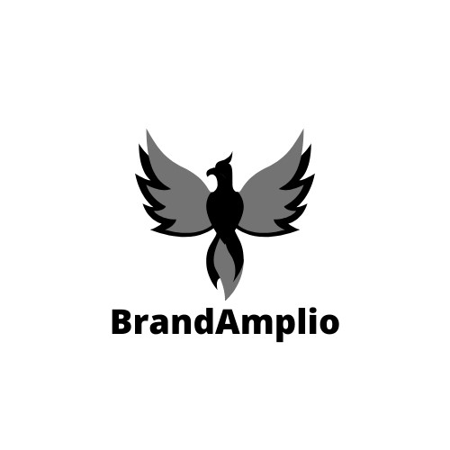

**Website SEO:**

Basic SEO to bring you on the first page of Google when customers search for your products.

**Social Media Management:**

Informative, Trendy and on brand content to increase engagement (likes, shares, followers) on Facebook and Instagram.

## 

## 

## Promotions:

Please note that discounts work **opposite** for brand building. It devalues the brand equity. The overall use of promotions and discounts should be limited to when you need to sell on the spot. Do not offer heavy discounts/sales everywhere.

It is prudent to run subscription promotions and wallet recharge promo code instead.

**Product Catalog:**

Low cost product catalog with all products Farmery has in the market along with the brand story/marketing angle on the page.

**Pamphlet:**

Showcasing why farmery, subscription offers, product highlight, new product launch, campaign news, QR code etc.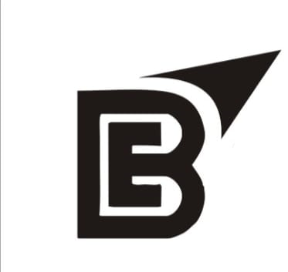

**Gifts that brings delight**

* **Spenders more than 3000 in a month:** 
  + a customized Milk Mug
    - Can be customized with Farmery branding, customer name/photo
* **Spenders more than 5000 in a month:** 
  + Jute bag with compartments [with branding]
* **Spenders more than 7000 in a month:** 
  + Insulated Milk/Chai/Coffee bottle [with branding]
* **Spenders more than 10000 in a month:** 
  + Basket/Kit with customized items [Spoon, shaker, Frother, personalized card]
* **New Customers/Acquisitions**
  + Catalog
  + Not recommended to send gifts to new customers as they will then constantly expect you to send something. Similar to heavy discounts this creates a problem in the long run.

**Gifts that brings more sales**

* Send a small potli of your non-dairy products. Can be sent to both existing and new customers.

## Suggested Sales Channels

* **Brand partnerships**

Brand partnerships with other companies help you leverage their customers and increase sales. It also gives your brand the trust it needs from other company customers so they become your customers.

Eg.

1. Haldiram/Bikaner/BTW uses Farmery’s milk in their products.
2. Local renowned bakeries using Farmery’s produce in their products.
3. Branded hostels all over NCR.
4. Popular Tea Spots/ Coffee shops
5. Ice Cream parlors
6. Other business consumers of dairy products
7. Renowned caterers willing to use farmery’s products in events & showcasing them.

Note: Even if the company sponsors a few liters of milk to these vendors in exchange for Farmery's product visibility alongside them, this is a positive investment.

**Marketing materials** can easily be made & personalized for the event/partnership.

* **Ecommerce Channels**

Presence on **Blinkit, Instamart, Big basket** can give an instant boost to sales (even if cost = sales), it might be a good idea to make your product visible in front of lakhs of consumers.

* **Offline Stores**

Presence on shelf of medium to large size marts, one stop shops, 24x7 format shops.

* **Online**

Online through mobile, website, Whatsapp as already in place.

Note: Brand Amplio has vendors for mobile app & website development & design. But we recommend getting a few proposals from other companies and choosing the best value option.

## 

## Online Visibility/Marketing angles:

* Mothers recommending farmery A2 cow milk for toddlers.
  + (the second best thing after mother’s milk)
* For People preferring authenticity, freshness & purity.
  + (farm to home - as pure as it can get)
* Elders of society [nostalgia] - Home like feeling and aged community recommending Farmery’s milk.
* Health conscience people - Gym enthusiasts, Dieticians, sports players, fitness freaks.

## 

## Suggested Campaigns

### **Garmi ko karein Stall**

Stalls at societies serving fresh tea, Milk shakes, coffee, fruit cream, sweets - milk cake. Along with sugar free options.

### **The urban village**

Door to door marketing - fresh from farms to home

### **Fit raho khush raho**

protein shakes, energy shakes, fruit yogurt near

* Fitso,
* gyms,
* sport academies,
* sports complex,
* summer camp in schools,
* district parks etc.

### **Nutrition boost** by Farmery

Farmery’s Milk advertised and used in these places:

* Coffee Stalls (hot coffee, cold coffee)
* Milkshake shops
* Breakfast shops serving lassi
* Chai shops (medium to large size) & Chai Cafe

## 

## 

## Samples & Past Work

**Jute Polti**

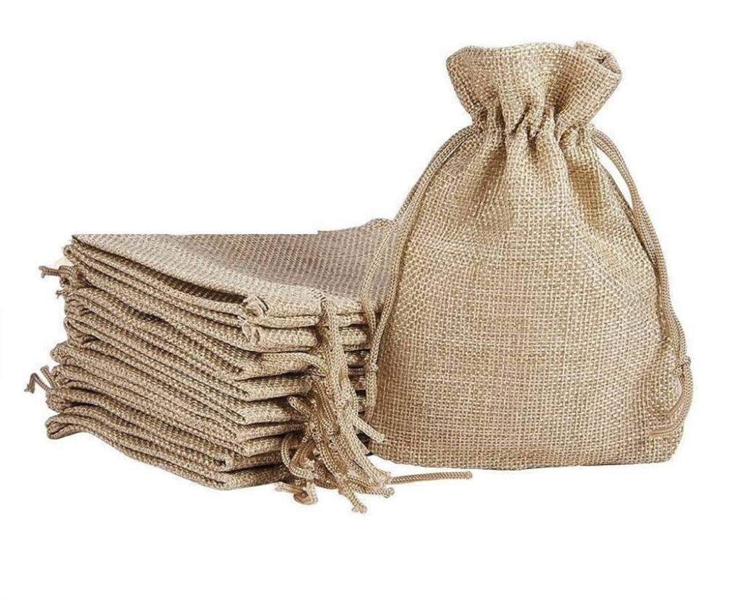

**Product redesigns**

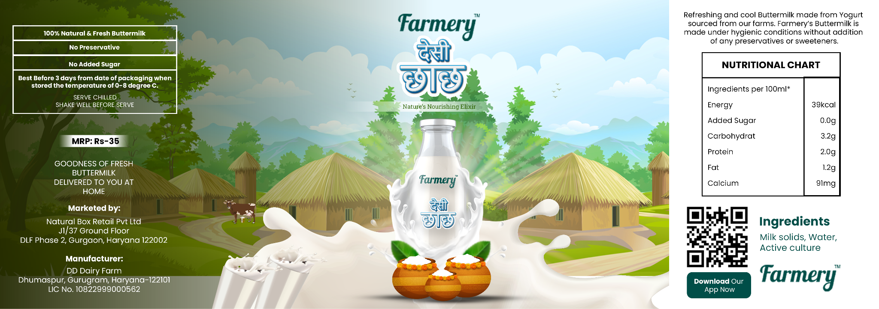

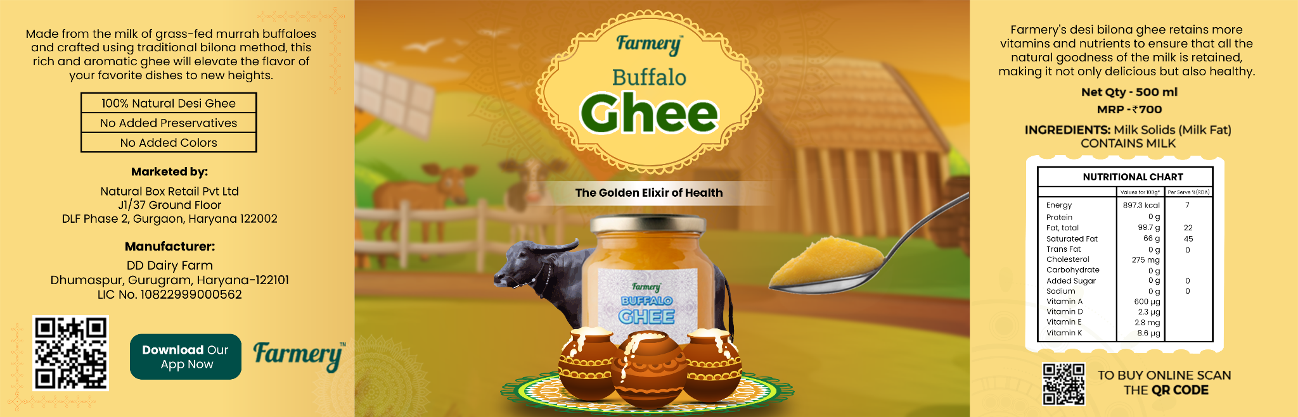

**Pamphlets**

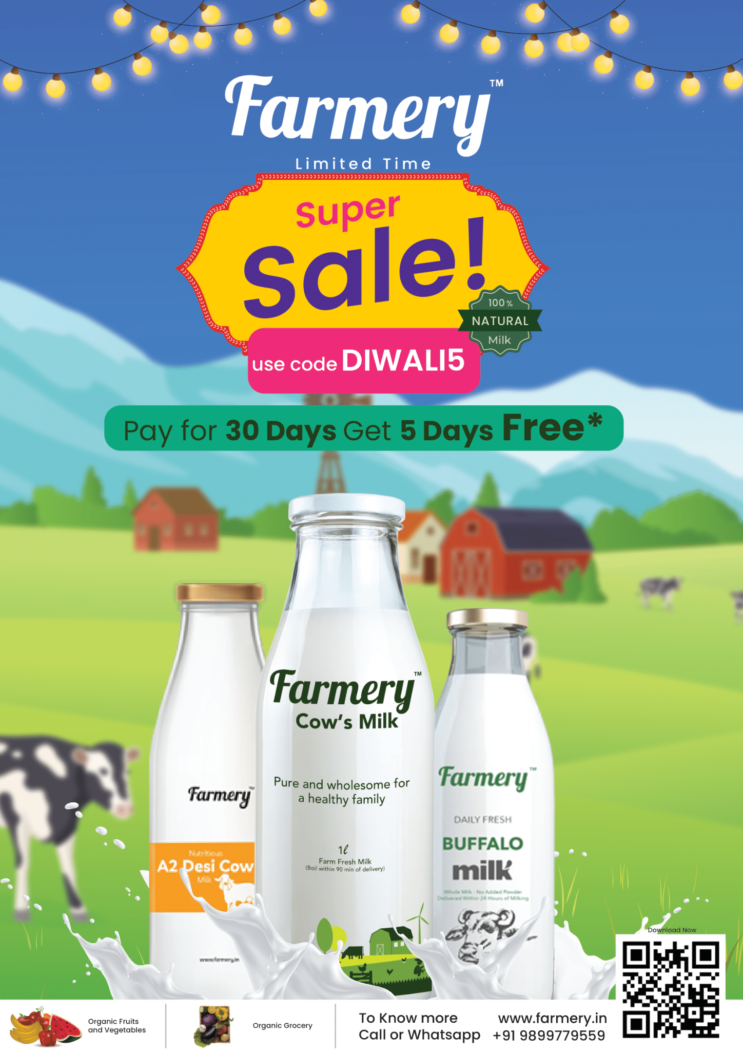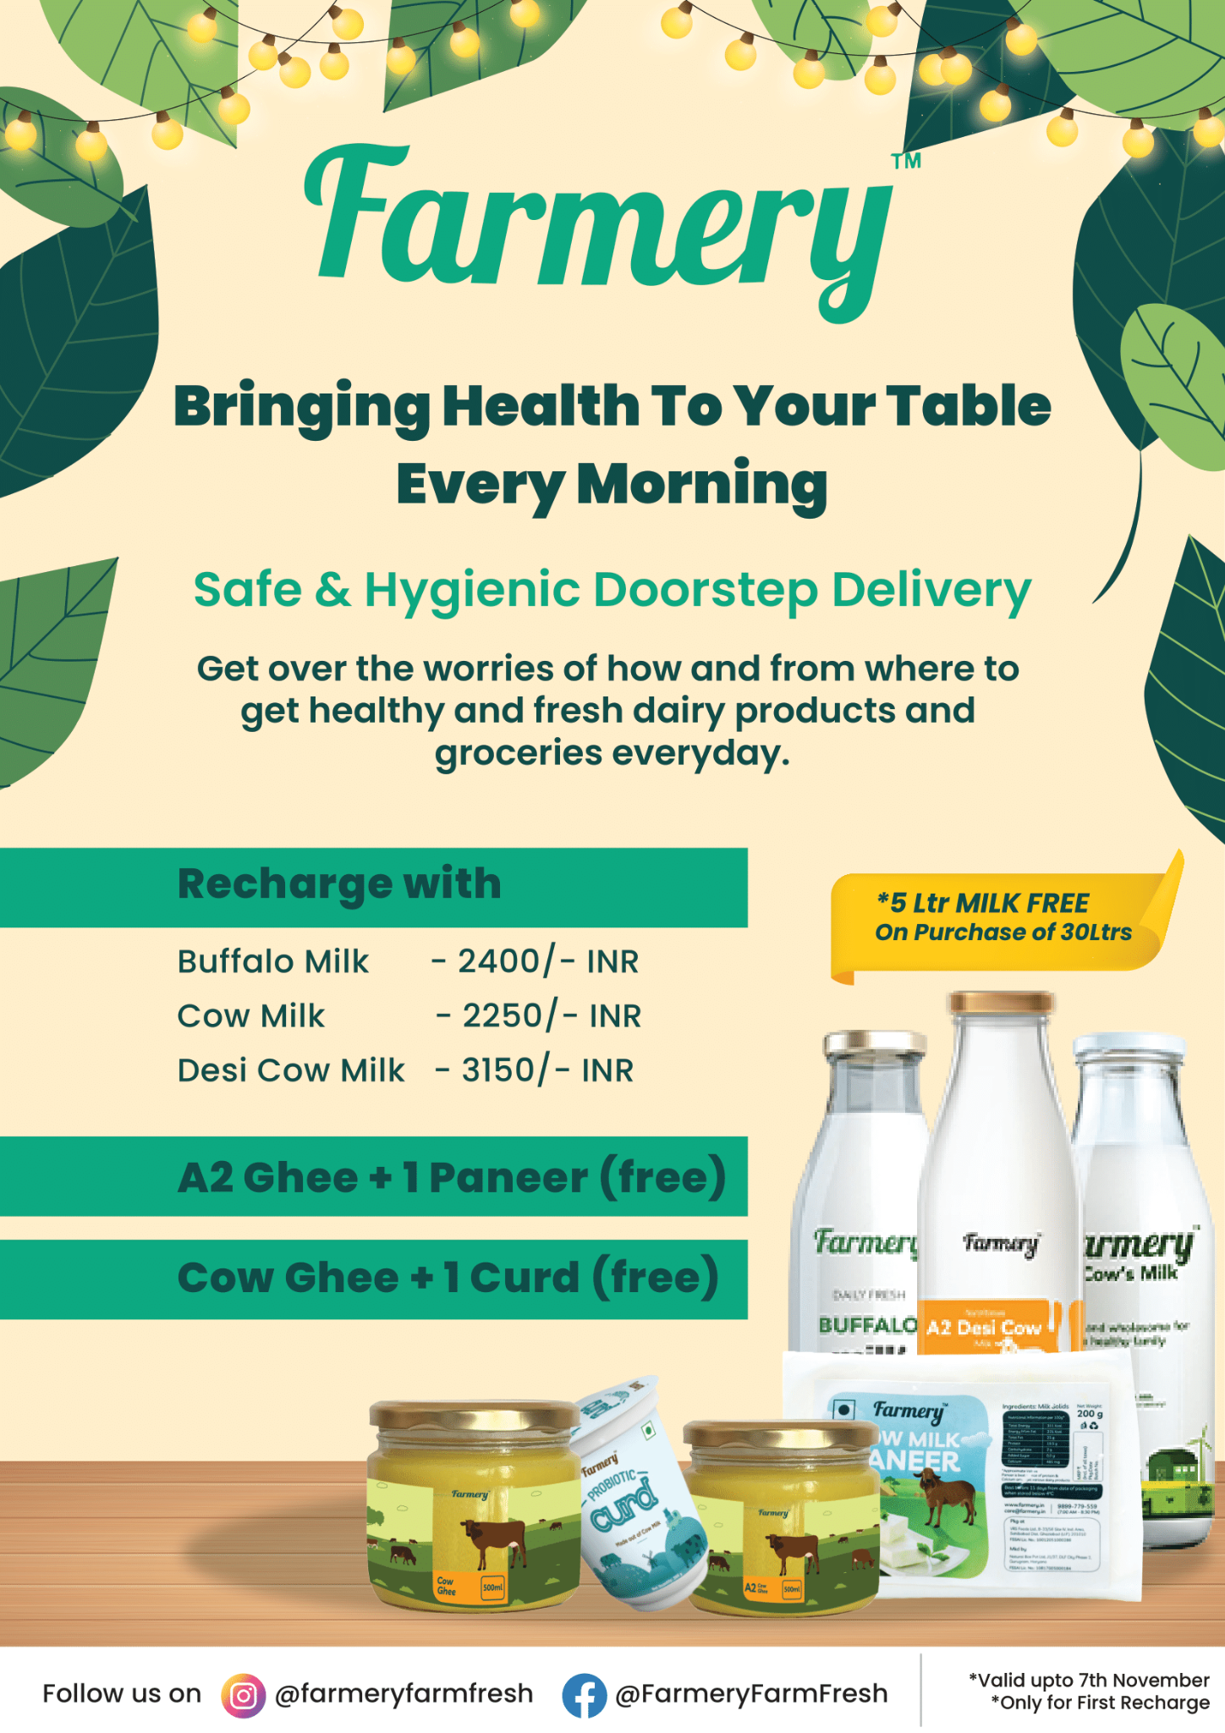

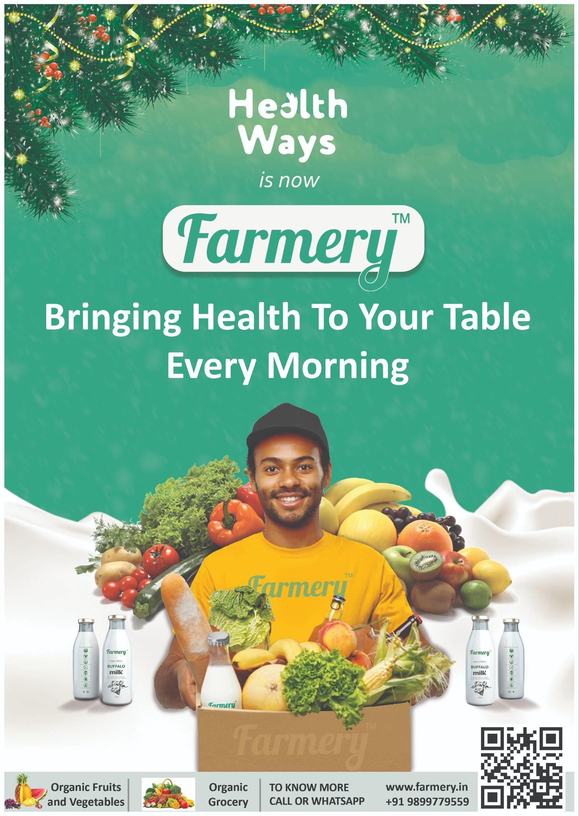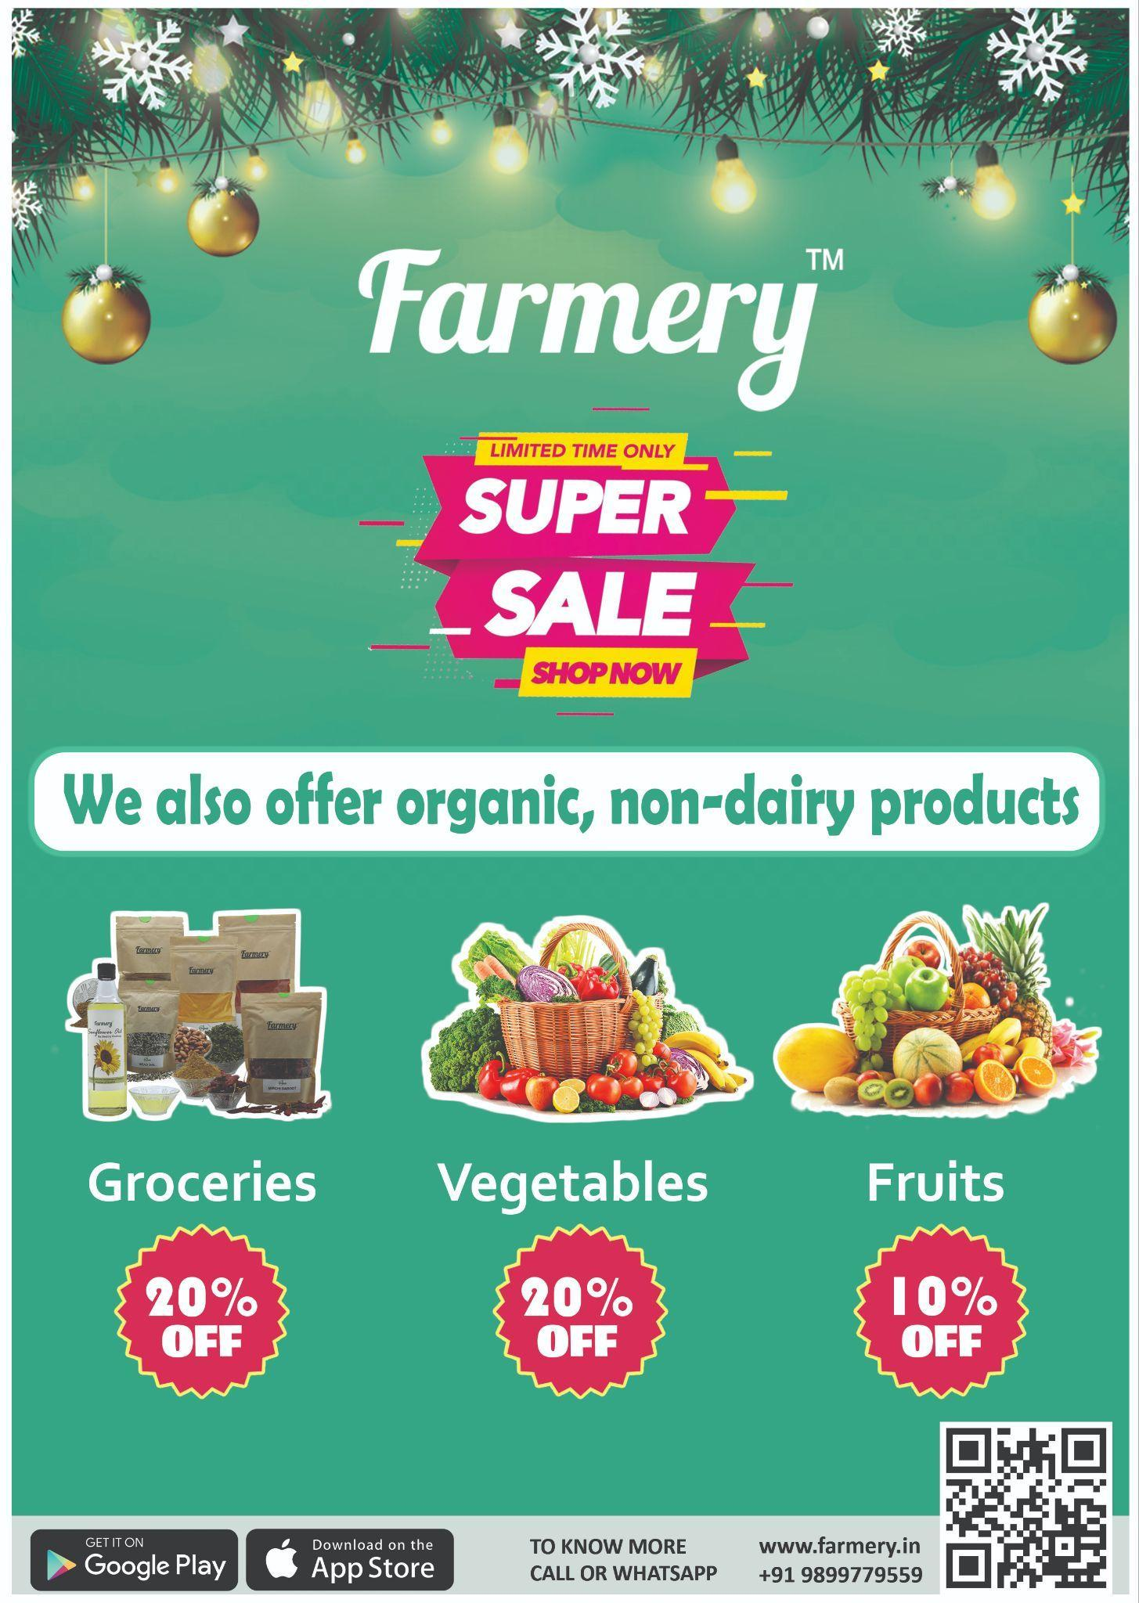

**Standee Designs**

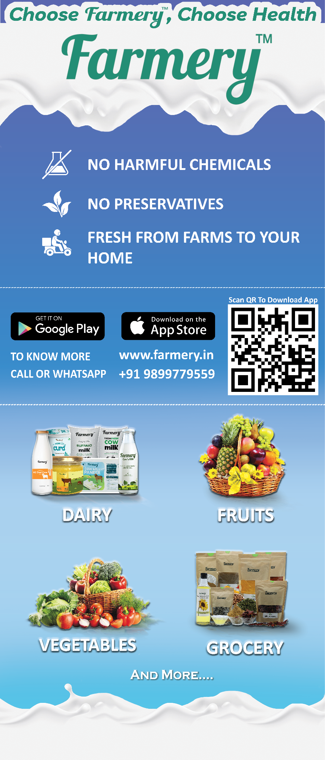

**Social Media**

* [**https://www.instagram.com/zupee_official/**](https://www.instagram.com/zupee_official/)
* [**https://www.instagram.com/pickrr_/**](https://www.instagram.com/pickrr_/)

**Mugs**

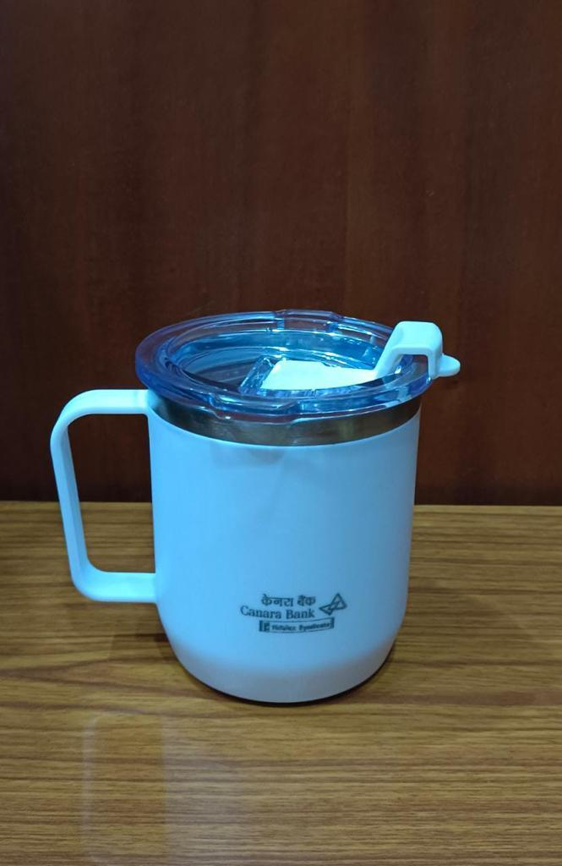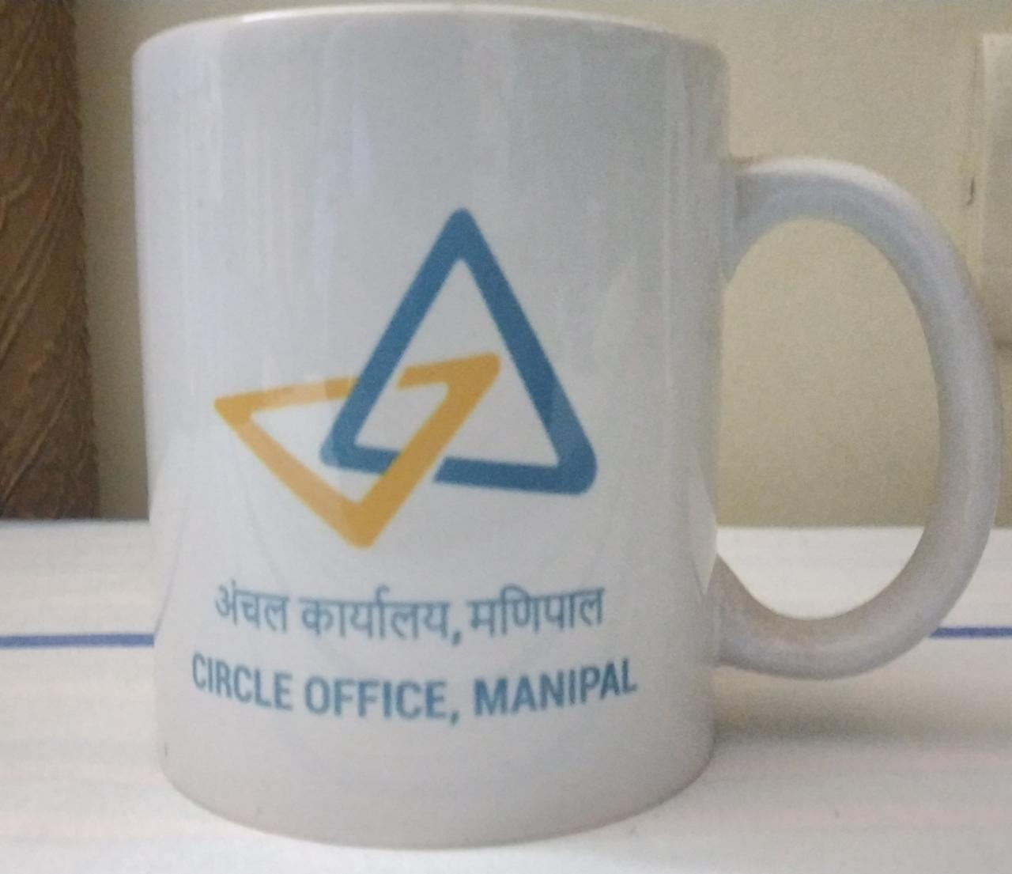

## Reference Links/Research into Dairy

* [Direct-to Consumers: A Winning Growth Formula for the Dairy Industry | 2022-01-13 | Packaging Strategies](https://www.packagingstrategies.com/articles/96604-direct-to-consumers-a-winning-growth-formula-for-the-dairy-industry)
* [Consumer Behavior for Milk and Dairy Products as Daily Consumption Products in Every Household—The Case of Kosovo (scirp.org)](https://www.scirp.org/journal/paperinformation.aspx?paperid=99273)
* [ES-6: Lesson 25. MARKETING OF MILK AND MILK PRODUCTS: AN ECONOMIC ASPECT (iasri.res.in)](http://ecoursesonline.iasri.res.in/mod/resource/view.php?id=4506)
* [Dairy Industry: Market Analysis And Marketing Strategies (pixelsutra.com)](https://pixelsutra.com/dairy-industry-market-analysis-and-marketing-strategies/)
* [Marketing Your Value-Added Dairy Products (psu.edu)](https://extension.psu.edu/marketing-your-value-added-dairy-products)
* [How to grow your dairy products’ business for increased revenue (bajajfinserv.in)](https://www.bajajfinserv.in/insights/how-to-grow-your-dairy-products-business-for-increased-revenue)